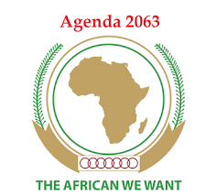

Liberia

**PROGRESS REPORT ON IMPLEMENTATION OF AGENDA 2063**

**NOVEMBER 2019**

# Brief of the country’s Socio-economic Status

Liberia is a country located in West Africa, with a population of approximately 4,243,475 as of 2016.[1] Females make up 51.1 percent of the population and male 48.9 percent. About 70 percent of the population was below the age of 35 and nearly half (44.5%) of the population was below the age of 15 years in 2016.

Liberia’s economy broke down due to a civil unrest during the 1990s and early 2000s. Since 2003, peace was restored and the country has had three successful democratic elections. The Government of Liberia has had several development plans, ranging from short, medium to long term: Liberia Rising Vision 2030 is the long term plan with a vision of “One People, One Nation United for Peace and Sustainable Development”. All other short and medium term plans as listed feed into the national vision; 150-Day Action Plan (2006), Interim Poverty Reduction Strategy (2007), Full Lift Liberia Poverty Reduction Strategy (2008-2011), and the Agenda for Transformation (2012-2017). The development plans from 2006 to 2017 raised Liberia from post-conflict emergency reconstruction and position it for future growth, as well as for Liberians to feel the benefits of peace. The country experienced significant growth and hit 7% growth rate in 2011 and was projected at 9% in 2012 due mainly to the expansion of mining activities. Then came the Ebola Virus Disease that eroded some of the significant gains. There were disruption of production processes across several sectors, household incomes dropped because of substantial loss of jobs and self-employment, economic activities slowed down due to the fear of the outbreak of the ebola, concession companies suspended investment plans and a number of expatriates were relocated to other countries.

The newly elected government of President George M. Weah came into office in January 2018 and initiated a 150-Day Action Plan that focused on quick win projects for the Government of Liberia. Later in October of 2018, a full developed medium term plan which is referred to as the Pro-poor Agenda for Prosperity and Development (2018-2023) was launched. This plan aims to:

1. To build more Capable and trusted state institutions that lead to a stable, resilient, and inclusive nation embracing its triple heritage and anchored on its African identity and
2. To provide greater income security to an additional one million Liberians, and reduce absolute poverty by 23 percent across 5 out of 6 statistical regions

The PAPD is built on four pillars and goals as stated below:

1. Power to the People- with the aim of empowering Liberians with the tools to gain control of their lives; reaching the furthest first and leaving no one behind
2. Economy and Jobs- to have a stable macroeconomic environment enabling private sector-led economic growth, greater competitiveness, and diversification of the economy
3. Sustaining the Peace- to have a more peaceful and unified society that enables economic transformation and sustainable development
4. Governance and transparency- to have an inclusive and accountable public sector for shared prosperity and sustainable development

Year one implementation of the PAPD has seen little gains as the country is trying to recover from the strong hit of the ebola virus and the fallen of prices on the world market of the country’s major export products, iron ore and rubber.

# Key strategies for Implementing Agenda 2063

**Policy Frameworks**

The Government of Liberia decided to implement one plan, thus, the current development plan, the Pro-poor Agenda for Prosperity and Development (2018-2023) encapsulated critical aspects of the Agenda 2063 and the SDGs 2030 which will be prioritized and domesticated. The alignments were done at the goal, target and indicator levels:

1. The goals of the four pillars of the PAPD were aligned to the corresponding SDGs for 2030 and the corresponding Agenda 2063 aspirations.
2. The high-level national targets of the PAPD were aligned to the corresponding SDGs 2030 targets and the corresponding Agenda 2063 targets.
3. The National Key Indicators (NKIs) of the PAPD were also aligned to their corresponding SDGs 2030 and Agenda 2063 indicators.

By doing these alignments, when a goal, a target, or an indicator of the PAPD is achieved, its corresponding goal/aspiration, target, or indicator of the SDGs 2030 and Africa Agenda 2063 is also achieved. This is the definition of implementing one plan.

**Institutional Mechanism**The Government of Liberia has a national implementation and coordination framework that is being used to coordinate, monitor and report on the Pro-poor Agenda for Prosperity and Development (PAPD), by extension the SDGs 2030 and Africa Agenda 2063.

**National Steering Committee (NSC**)

There is a National Steering Committee (NSC) which is the apex level coordination and decision-making body. The NSC is chaired by the President of the Republic of Liberia. The NSC is responsible for the overall management and coordination of the PAPD. The membership of the NSC comprises of the Minister of State for presidential Affairs, the Minister of Finance and Development Planning, Representatives of five key Development Partners, and Champions of the four pillars of the PAPD. The NSC is to hold meetings more frequently, respond more rapidly, and make substantive decisions more easily.

**Cabinet**

The cabinet is to provide guidance on policies and priorities that may affect the implementation of the PAPD. In collaboration with the Implementation, Coordination and Delivery Unit (ICDU), the cabinet monitors the goals, NKIs, and strategic objectives by assessing PAPD progress periodically, in accordance with the Results Framework. The cabinet facilitates inter-institutional coordination and collaboration to improve participation of various public and private sector actors directly involved in the implementation of the PAPD.

**Implementation, Coordination and Delivery Unit (ICDU)**

The ICDU serves as the secretariat to the National Steering Committee and the Pillar Working Groups (PWG). ICDU is responsible for the general coordination and monitoring of the PAPD. It provides support to and follow-up with ministries, agencies and commissions, and other key national and international stakeholders to ensure timely implantation of the agreed strategies and activities of the PAPD. The Secretariat works with the National Steering Committee, the cabinet, and the Multi Sectoral Planning Working Group to monitor interventions and ensure compliance with strategic goals of the PAPD. The ICDU works along with Pillar champions to plan and coordinate Pillar Working Group and Technical Working Group meetings. Periodic progress reports and other supporting documentation on the PAPD implementation is the responsibility of the ICDU.

**Multi-Sectoral Planning Working Group (MSPWG)**

The MSPWG comprises of heads of planning departments of ministries, agencies and commissions and representatives of the County Development Committees. Its function is to review sector plans, strategies, and interventions; identify linkages and synergies; imporove coordination and prevent duplication of efforts.

**Pillar and Technical Working Groups**

Each pillar is led by a Champion, with primary role to convene quarterly meetings to deliberate on progress towards the development outcomes and agree on resource requirements from a multi-sectoral perspective. The membership of the Pillar Working Group comprises of cabinet ministers (or their designates) and others by invitation.

The Technical Working Groups (TWGs) comprises of experts and specialists from ministries, agencies and commissions. They support the pillars. There are 12 TWGs. Their role is to ensure participation of multiple stakeholders to advise public planning, ensure wide-ranging buy-in and disseminate information throughout the implementation of the PAPD. Civil Society Actors, Development Partners, County Development Committee Representatives and Private Actors play advisory role within the TWGs. In close coordination with the ICDU, the TWGG’s undertake strategic and operations planning activities, including the development of the strategic plans and financial projections.

**Below is a graphic of the Plan Implementation and Coordination Framework**

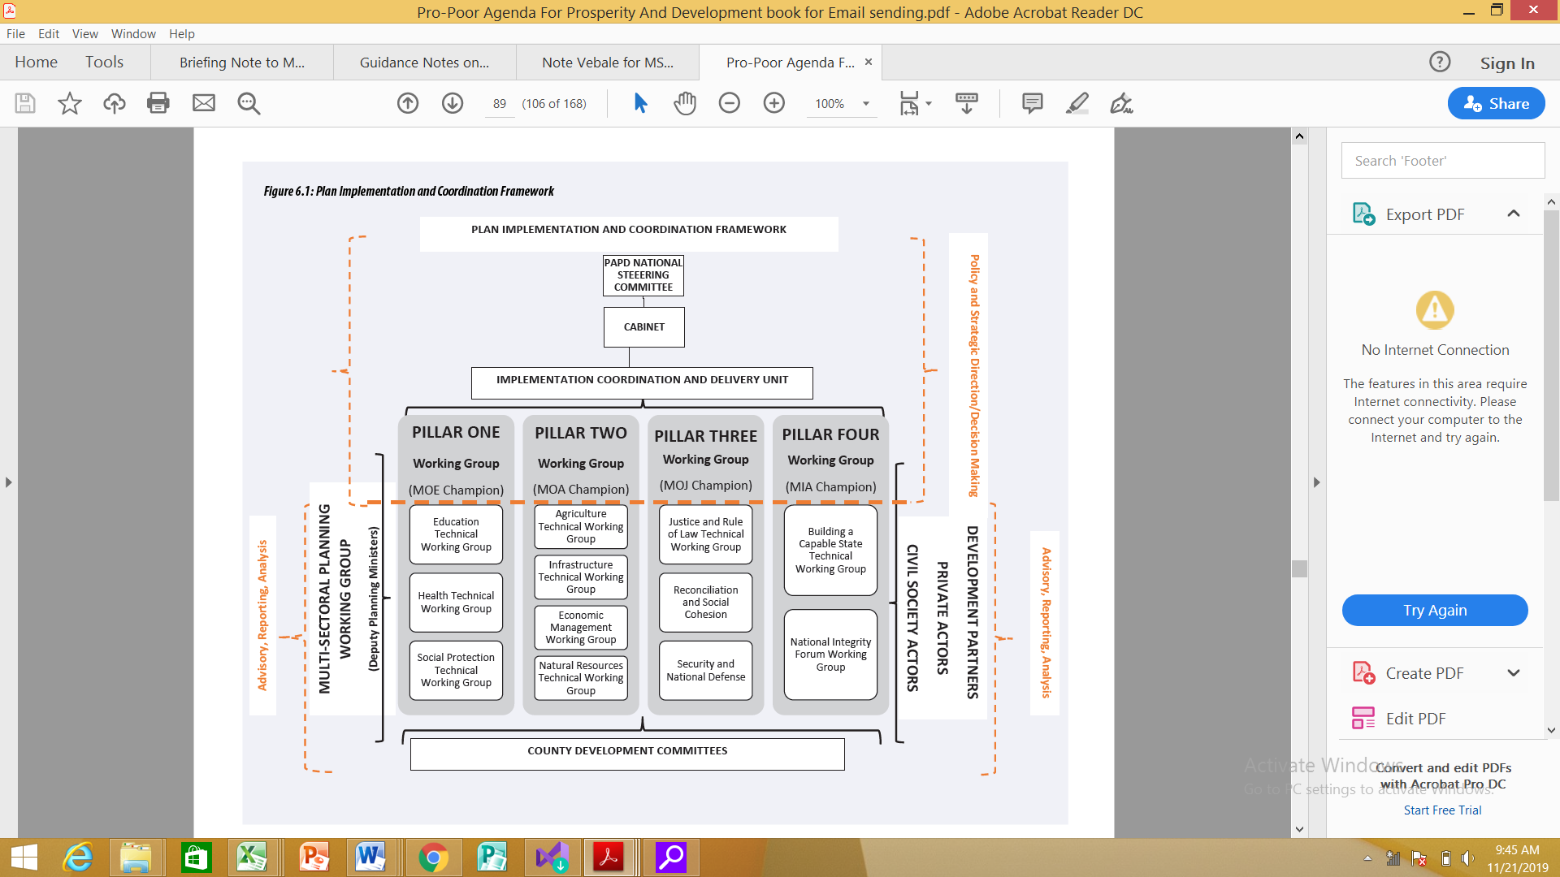

# Country level Status on the Implementation of Agenda 2063 Goals

Please see attached FTYIP Progress Reporting Template

# Challenges and Opportunities

There have been many challenges in implementing one plan (SDGs 2030, Africa Agenda 2063, and the PAPD). These challenges if not address during the short to medium terms might hinder progresses that are to be made.

1. Awareness/Advocacy- Even though, back in 2017, the Government of Liberia, with funding from UNDP carried on a nationwide awareness in domesticating the SDGs and Agenda 2063, many Liberians from different walks of lives still have little or no knowledge about the Africa Agenda 2063, its goals and indicators. Reason being there was no sustainability plan for the awareness.
2. Data- There is a huge challenge with data as it relates to monitoring and reporting on the SDGs 2030, Africa Agenda 2063 and the PAPD. Specifically, the Africa Agenda 2063 was adopted in January 2013, and there are not enough data available to baseline indicators of the Agenda during that period, especially at the disaggregated levels; gender, region, age group, amongst others. The available data is either not updated or not in the required format for the Africa Agenda 2063. To track the progress of the Agenda 2063 means, baseline data should be made available. Progress cannot be tracked without adequate and evidence based data. Liberia Institute for Statistic and Geo-Information Service (LISGIS), the country’s national statistical house are not conducting regular scheduled surveys for data collection due to the tight fiscal space on the country’s national budget.
3. Financing- Liberia’s annual national budget is a little over 500million United States Dollars. This is not sufficient to finance public investment projects are aligned to some of the goals of the Agenda 2063 as well recurrent expenditure. To this, the Government of Liberia has a serious challenge when it comes to financing the implementation of its local, continental and global agenda.

Liberia is a youthful country with over 70% of its population below the age of 35 years. Investment in capacity building (bachelor, master and PhD degrees) in the areas of planning, monitoring and reporting, sustainable development, international development and other relevant fields of studies in these youthful citizens will improve their knowledge and accelerate the implementation of the Africa Agenda 2063.

The challenges listed, awareness/advocacy, data, and financing, when properly addressed, are huge opportunities to accelerate the implementation of the Africa Agenda 2063.

# Key lessons learnt

The first step the Government of Liberia took in domesticating the Africa Agenda 2063 and the SDGs 2030 was to create public awareness of the SDGs 2030 and Agenda 2063. The objectives of the public awareness were, to engender public awareness on how the domestication of the Agendas 2030 and Africa 2063 to national and sub-national development plans will be conceptualized, to generate understanding from sub-national stakeholders as their roles in the implementation of the Agendas 2030 and Africa 2063, as well as to explain to regional stakeholders the benefits and challenges associated with implementing the both agendas.

Two key lessons learnt from implementing the Agendas, Africa 2063 and SDGs 2030 are:

1. Useful Communication Medium- The idea to engage students from the local communities served as a useful means through which the message of the awareness could be disseminated. This idea instilled a sense of ownership among local community dwellers who felt the need to identify with the message considering the fact that their “own children” could conceptualize the message and deliver same to them.
2. There has not been much progress made with implementation and reporting due to limited financial resources and lack of quality data. This has slowed down interventions as well as reporting. Lessons learnt here is that, Government needs to mobilize more funding from both bilateral and multilateral partners in order to fast speed and report on interventions of the local, continental and global development frameworks.

# Conclusions

Liberia is an underdeveloped nation, still recovering from ebola virus hit, and the fall of prices on the global market of its major commodities (iron ore and rubber). The country’s national strategic plan is aligned to the SDGs 2030 and Africa Agenda 2063 but progress towards goals and aspirations of both agendas is slow due to insufficient funding to implement projects and programs as well as limited data to report on the implementation. To adequately report on the implementation of the Agendas, Africa 2063 and SDGs 2030, resources must be pulled towards data collection and reporting.

1. LISGIS, OP cit, 2016